Posting LMC Library Streaming Videos in Canvas

The LMC Library subscribes to two main streaming video services, Films on Demand and Kanopy.
Films on Demand: http://losmedanos.libguides.com/filmsondemand
Kanopy: http://losmedanos.libguides.com/kanopy
Films on Demand includes over 29,000 full length closed captioned videos from producers like HBO, Ken Burns, NOVA, PBS, Media Education Foundation and many more. Please look for your videos in Films on Demand first. This is Films on Demand:
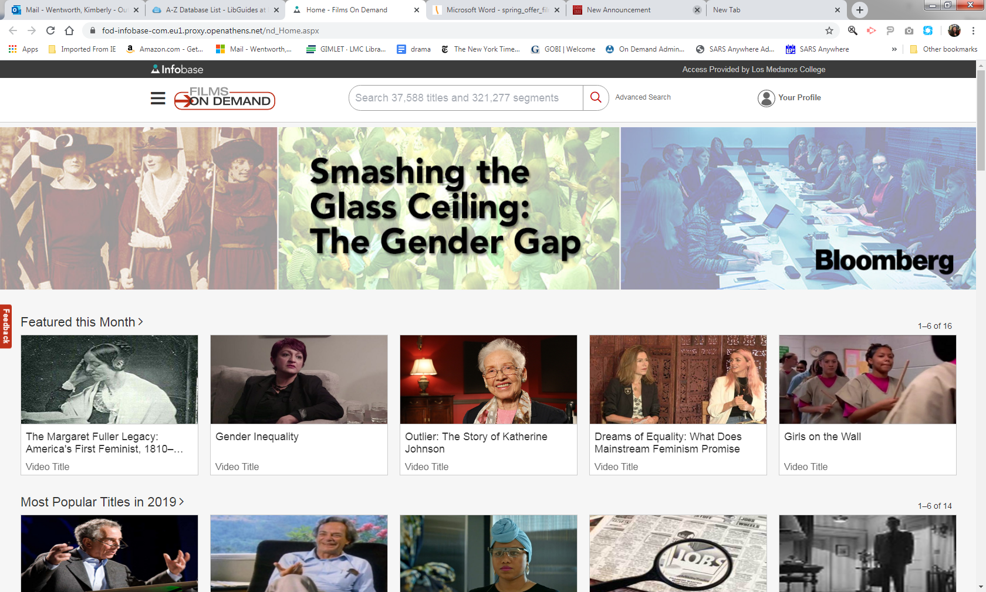

Films on Demand can be embedded in Canvas. Here are instructions:
- Search Films on Demand http://losmedanos.libguides.com/filmsondemand to find a film that you would like to post in Canvas.
- Open Canvas and go to the place where you would like to embed the video.
- Click in the V icon.
- Select Films on Demand from the pull down list.

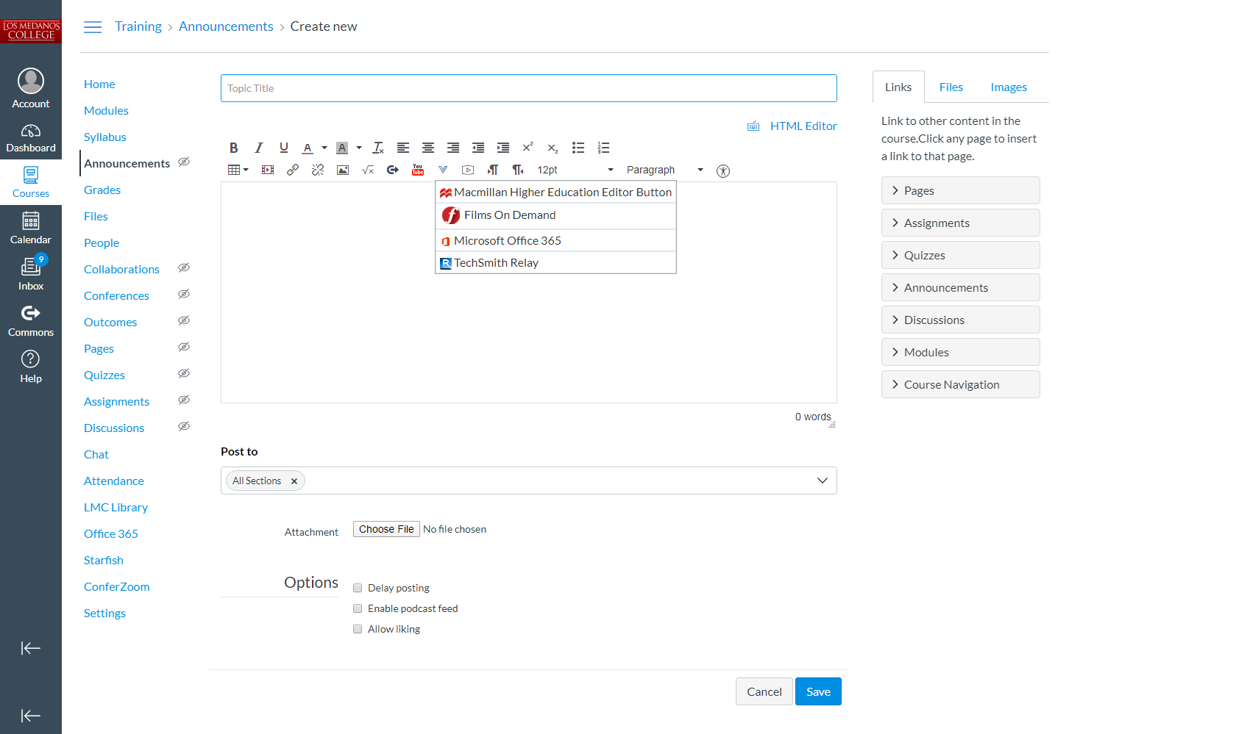

- Type the name of the video in the search box. (You can search for videos in here, but I think it is easier in the full website.)

- Select the video or segment that you wish to embed in Canvas.
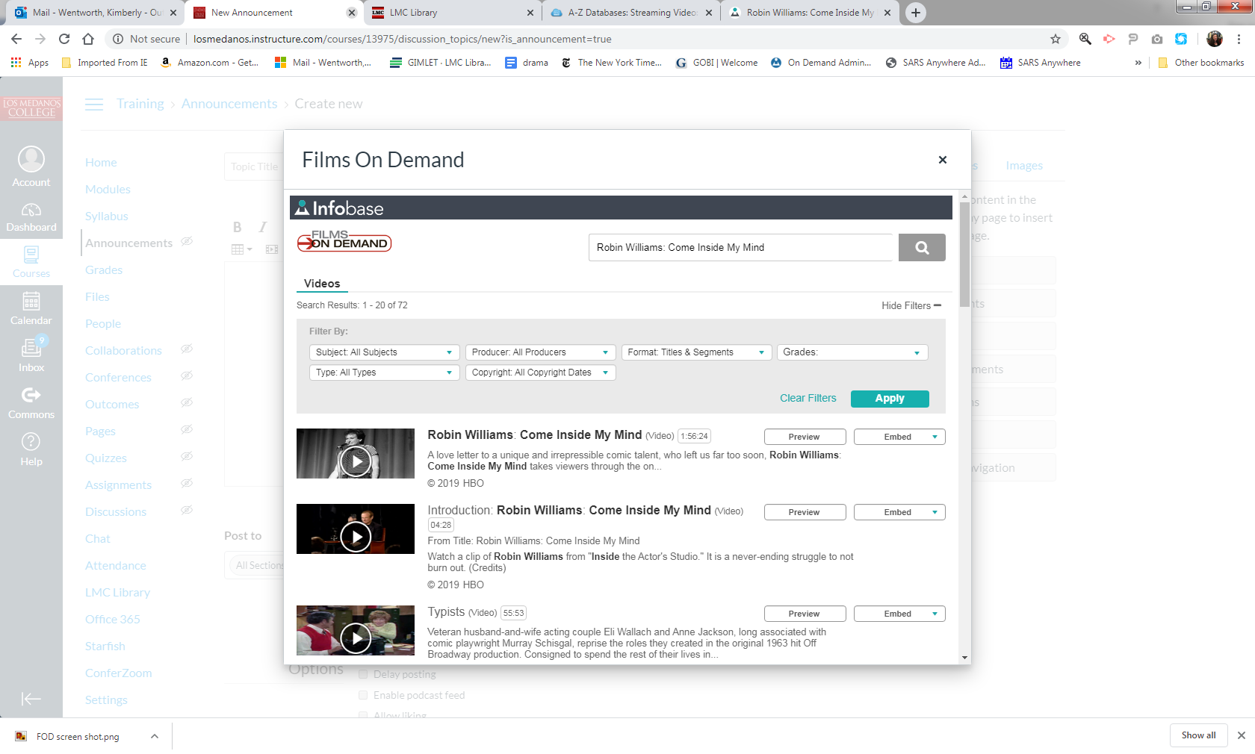

- Click the embed button.

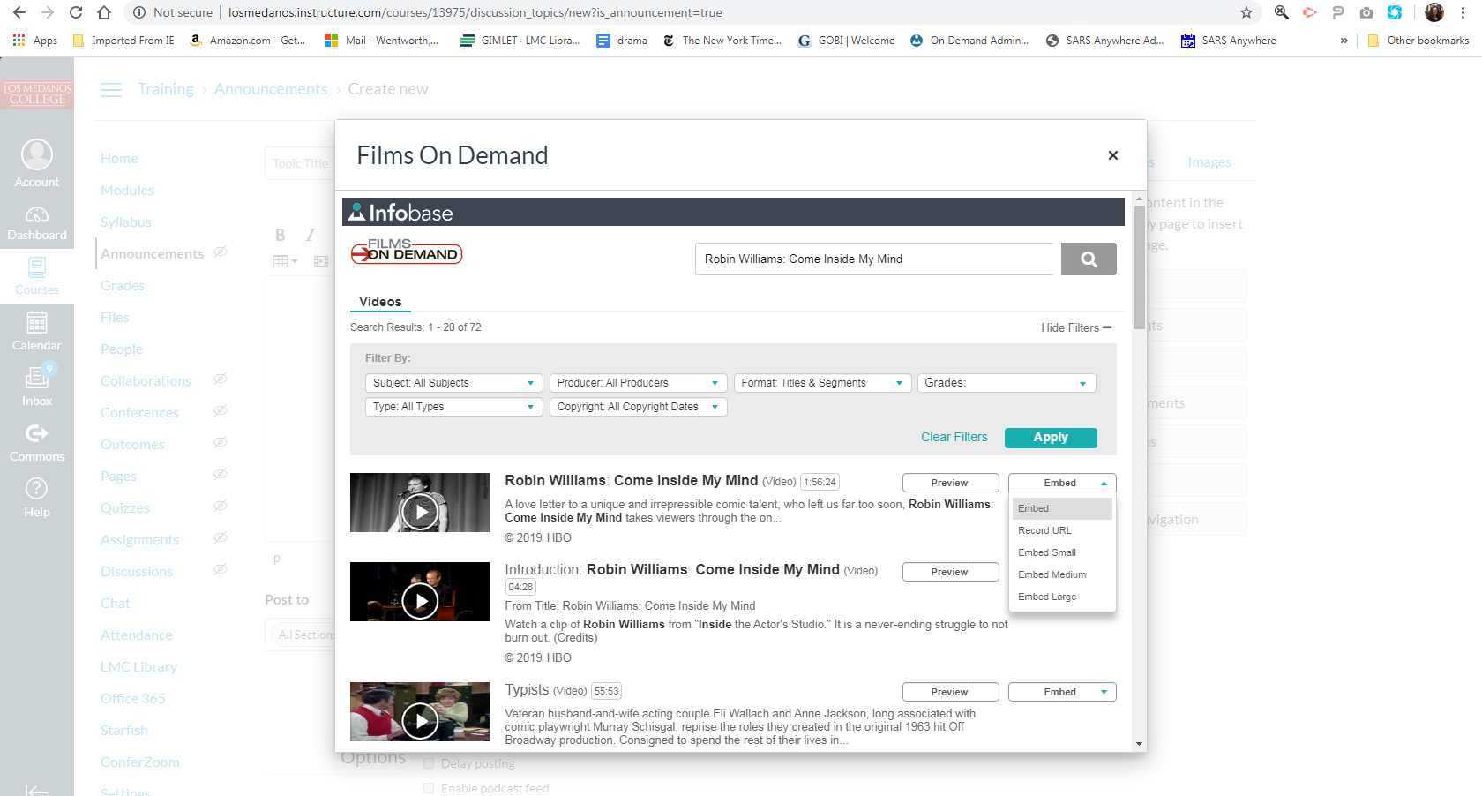
- You can choose if you want to embed a link or the video into Canvas. Either way is fine.
- Make sure you click Save.

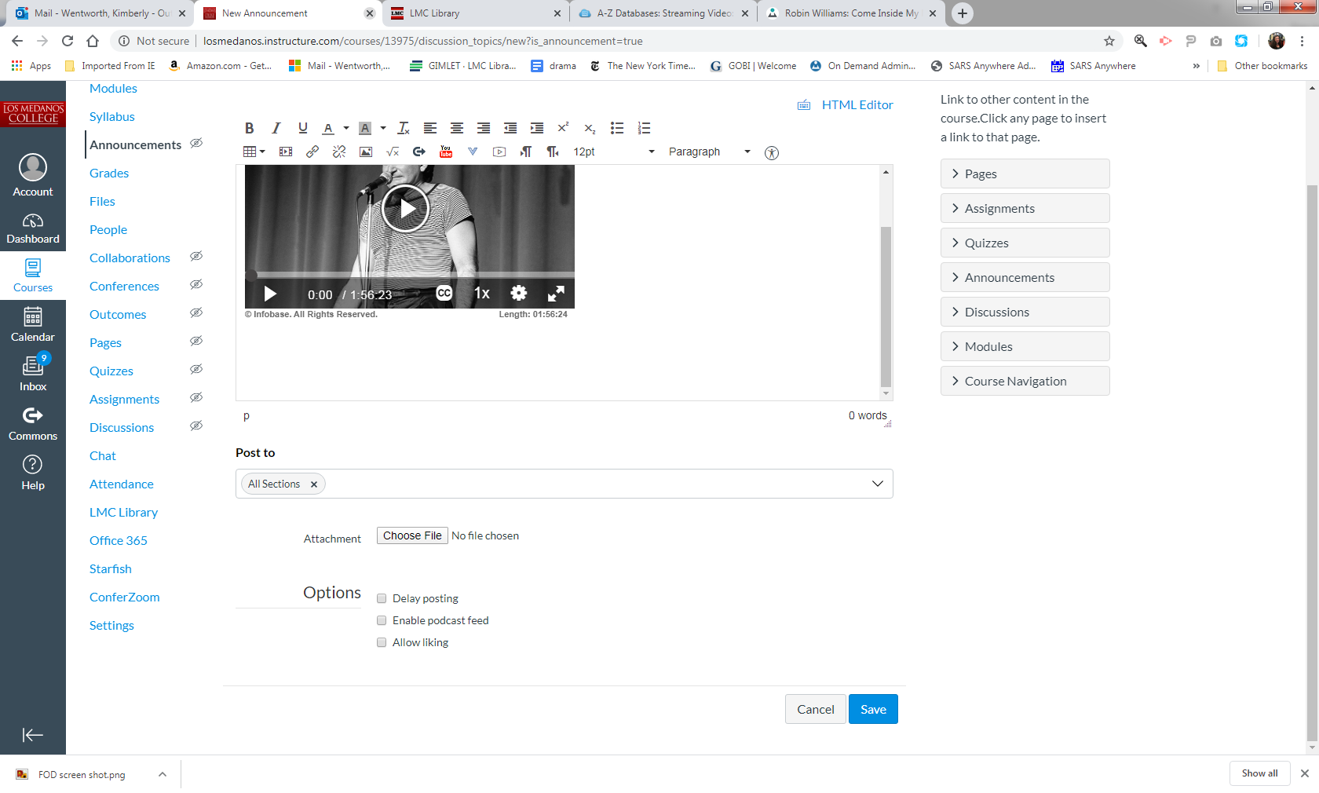
That’s it. You’re done. Good job!
Kanopy provides access to more than 26,000 films. Kanopy offers award-winning collections including titles from PBS, BBC, Criterion Collection, Great Courses and more.
*Films on Demand and Kanopy are two different companies, like Hulu vs. Netflix.

Kanopy looks like this:

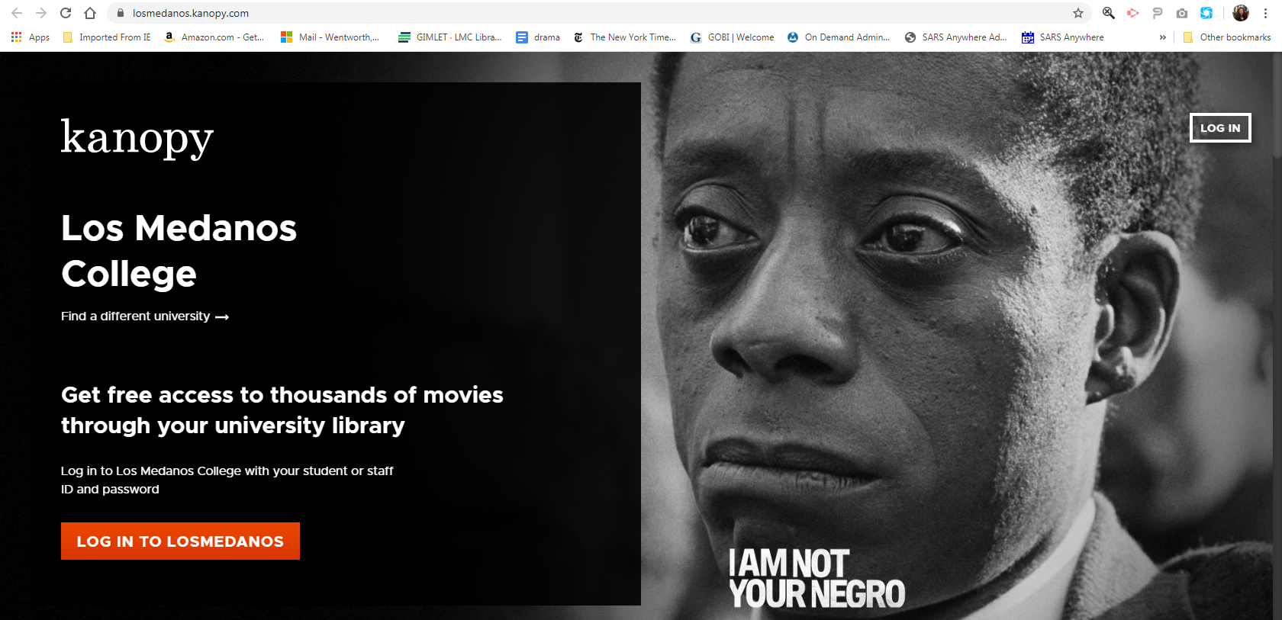
- Kanopy: http://losmedanos.libguides.com/kanopy
- Click Log in to Los Medanos.

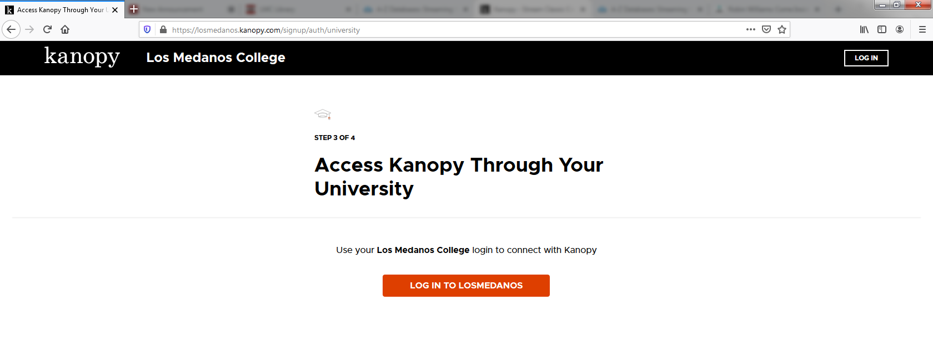

- Click Log in to Los Medanos.

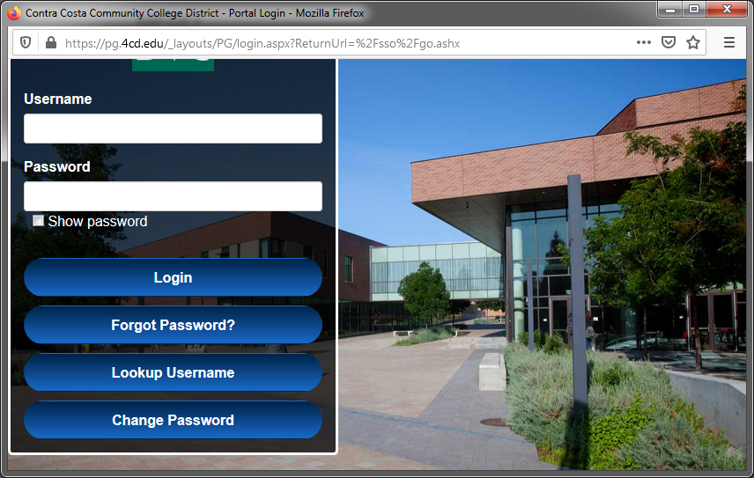

- Log in using you Canvas/InSite credentials.

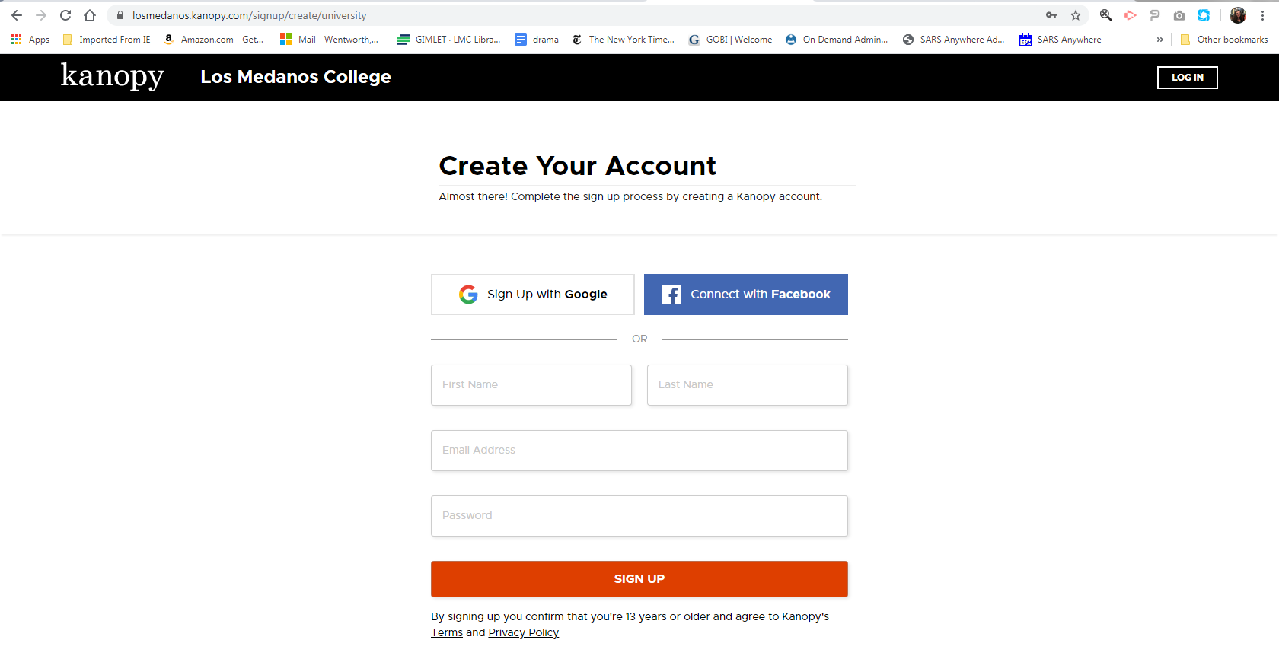

- Create a Kanopy account.

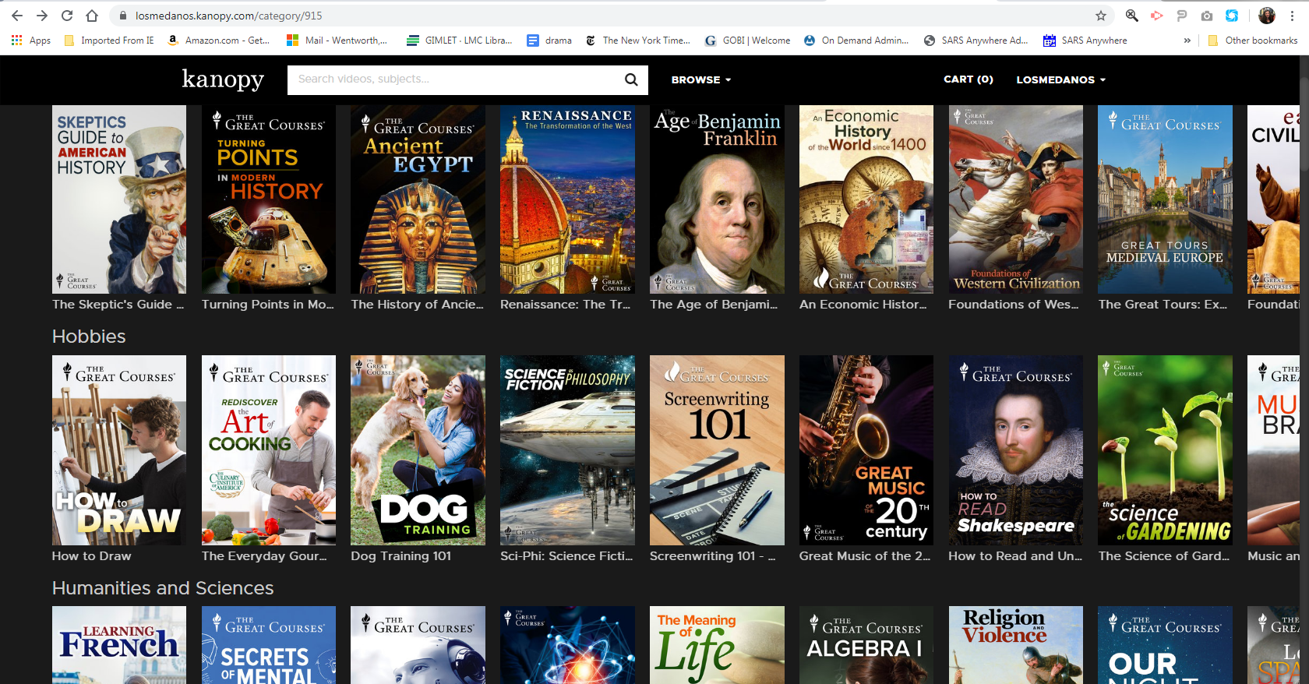

- Search for a video that you want to post in Canvas.
- Click on it.

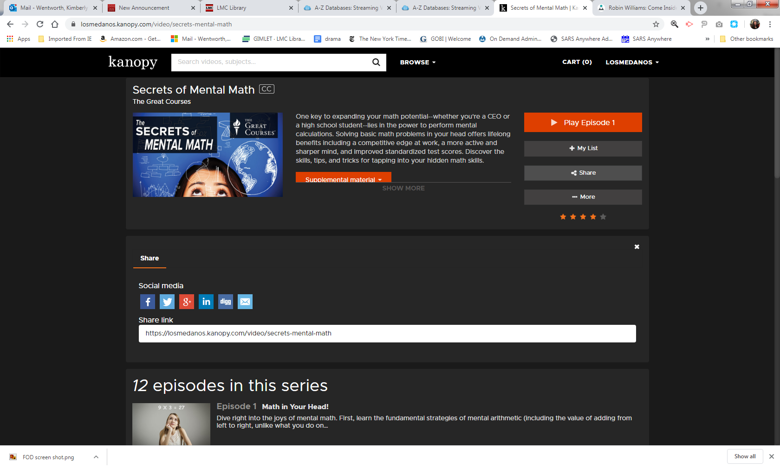

- If your students have not done so already, they will need to create a Kanopy account. If you send them a Kanopy link to a specific video, and they do not have a Kanopy account already, they will not be able to open it.

- Tell them to go to Kanopy: http://losmedanos.libguides.com/kanopy
Create and account.
Then search for and watch whatever film you want them to watch (Ex. Secrets of Mental Math). They can easily search for it by title themselves.

- Or you can have them all create Kanopy accounts. Then you can click on the Share button and copy and paste the link into Canvas.

That’s it. You’re done. Good job!

This website lists all the ways that you can contact a librarian if you need assistance: http://losmedanos.libguides.com/contactalibrarian
More faculty resources can be found here: http://losmedanos.libguides.com/faculty

Good Luck!

